Dis-Afr-Democratic Republic of the Congo-Mushenge, West Kasai Province- *Ndop* figure 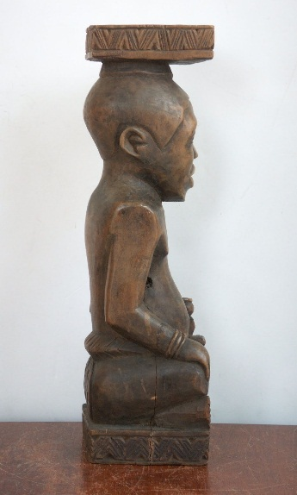 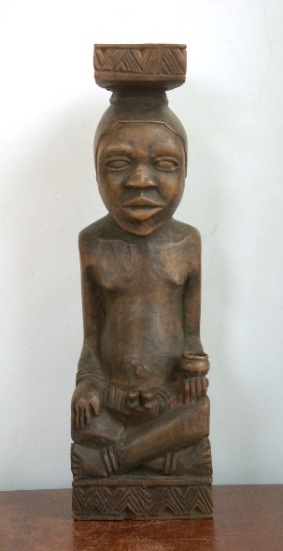 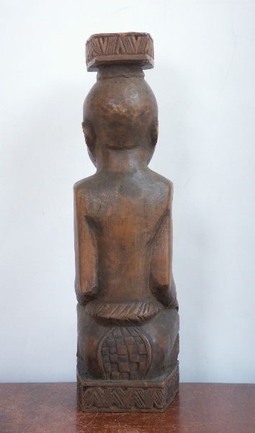 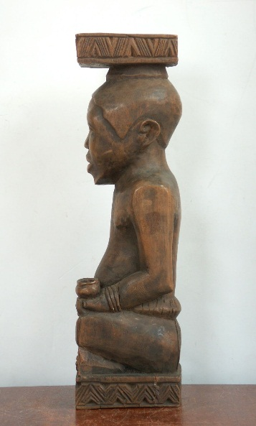

**Formal Label:** Democratic Republic of the Congo, Mushenge, West Kasai Province, *Ndop* figure

**Accession Number:**

**LC Classification:**

**Date or Time Horizon:** 19th century

**Geographical Area:** Democratic Republic of the Congo, Mushenge, West Kasai Province

**Cultural Affiliation:** Kuba Kingdom

**Medium:** camwood (*crossopterix febrifuga*)

**Dimensions: H** 12.25 in **Weight:**

**Provenance:**

**Condition:**

**Discussion:**

Ndop were personal wooden likenesses commissioned by each king (*nyim*) of the Kuba (Bakuba or Bushongo)Kingdom of Central Africa upon his investiture in office. The original Kuba had migrated during the 16th century Bantu migrations from the north into the region of the modern Democratic Republic of the Congo bordered by the Sankuru, Lulua, and Kasai rivers. In this region the Kuba Kingdom incorporated the Bantu speaking Kuba immigrants as well as the indigenous Kete, Coofa, Mbeengi, and Twa Pygmies.

Each *Ndop* likeness bore a small crest or *ibol* on its back to identify the Kuba king (Adams 1988). These likenesses actually acted as surrogates for the king in his absence. In fact, it was believed that they were his spiritual double and that should anything harm the king it would be reflected on his likeness (Vansina 1972). The practice of sculpting likenesses of each Kuba king lasted from the 17th to the 19th centuries when pressures of external religions were being felt. The wood sculpture of this particular king’s likeness does not have to have been accurate as a portrait since only those attributes and demeanors that are considered positive are emphasized, since the likeness literally stands as a monument for those members of the kingdom to emulate. For instance, this *ndop* figure sits cross-legged on a raised platform with a demeanor that expresses both evenness of temper and composure. The cup in his left hand suggests a non-aggressive pose of the *nyim*, and his belt, bracelets, anklets, and royal headdress define his royal paraphernalia. *Ndop* figures were believed to represent the alter-spirit of the *nyim* and serve as a point of contact with his spirit. Should any likeness become too worn with age a new one could be commissioned and re-instituted in the same way as the original, thus successfully transferring the alter-spirit to it.

The likeness was regularly placed in the harem, and when a woman of the harem was about to give birth, it was placed near her to insure a safe delivery. Upon the death of the Kuba King, the *Ndop* was removed to a strong room only to be taken out for special rituals honoring the deceased kings (Vansina 1972).

**References:**

Adams, Monni. 1988. "18th-Century Kuba King Figures," African Arts, **21** (3): 32–38+88.

Rosenwald, J. 1974. "Kuba King Figures," African Arts, **7** (3): 26–31.

Vansina, J. 1972. “Royal statues among the Kuba.” In D. Fraser and H.M. Cole, eds. African Art and Leadership. Madison: University of Wisconsin Press.